Press Facts
Moulding sands for the foundry industry
Jung Instruments: Quick digital bentonite testing reduces casting defects
Electronic wet tensile strength test provides results in a minute.
Viersen, Germany, August 22, 2018 Jung Instruments’ new WJ1 tester automatically measures the wet tensile strength of moulding sands and displays the measured results as digital readings in N/cm² within a minute. These measurements increase process security before the casting process starts, reducing overall reworking and rejections.
The wet tensile strength of moulding sands largely depends on their content of active bentonite. Too little bentonite may lead to cracks or spalling in the sand mould, resulting in casting defects, such as scabbing.
With the new WJ1 tester, foundrymen can measure the wet tensile strength in next to no time and adjust the bentonite content as required.
The innovative system is the world’s first to operate fully electronically, using a calibrated load cell, a digital display for the measured results and, as an option, an interface for data transfer.
Carsten Jung, Development Manager at Jung Instruments, sees clear advantages for his customers: “As the measurements take place fully automatically, they are in no way influenced by subjective factors, as for example the skills of the operator. And the instrument is very easy to use: All the operator has to do is push a button for the measurement to start and take the readings. The instrument does not have to be attended as it performs the measurement. This saves time and money, as the operator can perform other tasks while the measurement is going on.”
The technology in detail
The tester measures the tensile force at which a standard test specimen breaks in a tensile test. The specimens are produced by filling sand into a testing tube and pressing in a liftable ring at the top end of the tube. The tube with the specimen is placed into the instrument and heated at approximately 300 °C. The heating is continued until the fracture surface that will result from the imminent breakage will have reached the top rim of the specimen tube. According to practical experience, this will take approximately 35 seconds. By this heating procedure, a condensation zone is generated in the specimen which in sand casting is a critical parameter for the avoidance of scabbing.
Upon reaching the end of the heating time, the ring is automatically pulled upwards causing the specimen to break. The tensile force measured during the breaking process is equal to the wet tensile strength. It is indicated on the digital display in N/m².
The entire procedure takes place fully automatically. The operator starts the measurement by the push of a button and can take the readings within a minute.
420 words including introduction

About Jung Instruments:
Jung Instruments GmbH, founded in 2008, develops and manufactures measuring instruments for the foundry industry. Within its product range, the company specializes in standard-conforming moulding sand testers, which it designed in cooperation with the German Foundry Association (BDG) and the Austrian Foundry Research Institute (OGI). The instruments conform to BDG Guidelines.
Jung Instruments not only manufactures devices, but also offers a wide range of comprehensive services, including on-site maintenance and servicing activities. The company calibrates its instruments by means of gauges calibrated by the German Calibration Service (DKD). It is authorized to issue calibration certificates.
Since 2011, Jung Instruments has been certified according to ISO 9001:2008.
The company currently has seven employees at its headquarters in Viersen.
Contact:  Jung Instruments GmbH  Erwin Jung  Industriering 52  D-41751 Viersen/Germany  Fon: +49 2162 26 64 790  Fax: +49 2162 26 64 798  www.jung-instruments.de  info@jung-instruments.com | Press contact:  VIP Kommunikation  Dr.-Ing. Uwe Stein  Dennewartstraße 25-27  D-52068 Aachen/Germany  Fon: +49.241.89468-55  Fax: +49.241.89468-44  www.vip-kommunikation.de  stein@vip-kommunikation.de

Figures:
Link for downloading image files in print quality:
Photos Jung Instruments
Fig. 1: The new WJ1 tester launched by Jung Instruments measures the wet tensile strength of moulding sands within a minute.  File name:  Jung-Instruments-2018-07_04 | 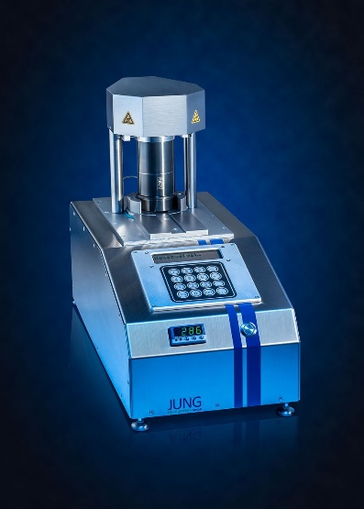
Fig. 2: The sand is heated for approx. 35 seconds. Then the test ring is lifted from the tube causing the specimen to break.  File name:  Jung-Instruments-2018-07_01.jpg | 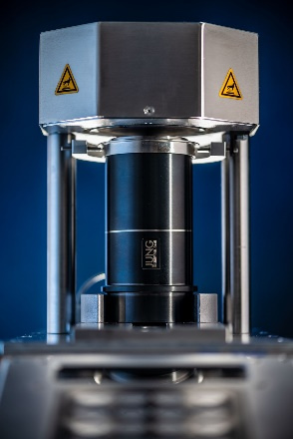
Photos provided by Jung Instruments

